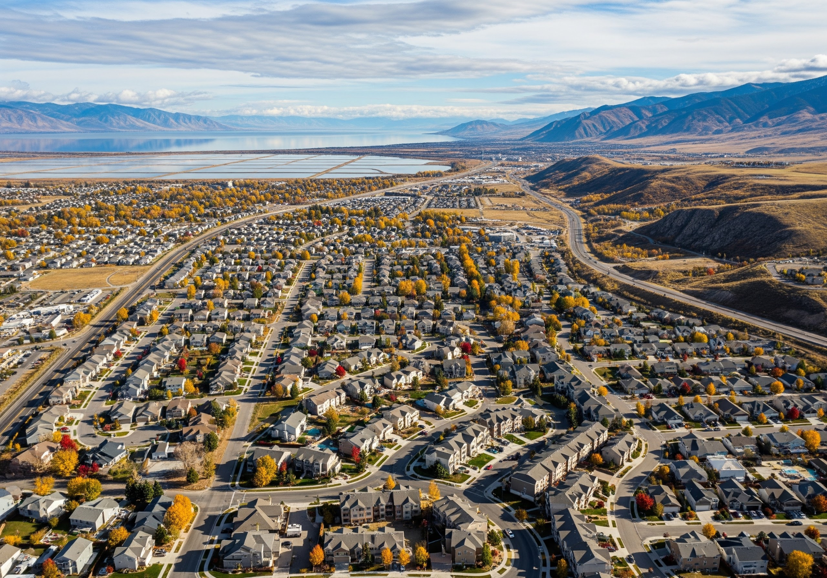


Section 108 Loan Guarantee Application

Introduction and Project Overview
This narrative supports the application by Davis County, Utah, for a Section 108 Loan Guarantee from the U.S. Department of Housing and Urban Development (HUD). The requested loan proceeds will be used for a Permanent Supportive Housing fund that the county will use to fund land acquisition, infrastructure and soft costs to facilitate the development of a Permanent Supportive Housing (PSH) project in Davis County, Utah. This critical initiative is designed to address a persistent community need for stable, affordable housing integrated with supportive services for individuals experiencing chronic homelessness or who are at risk of homelessness.

This project aligns directly with Davis County's Consolidated Plan priorities, specifically focusing on expanding the supply of affordable housing and providing essential services to vulnerable populations. The project represents a coordinated effort between Davis County, local service providers, and the private development community to create a sustainable solution to chronic homelessness and housing instability.

II. Community Development Objectives

A. The Challenge of Homelessness in Davis County
While often perceived as a challenge unique to urban centers, Davis County faces a significant and growing need for deeply affordable housing options with integrated support. In 2021, during the annual Point-In-Time Count; Davis County documented 71 households experiencing homelessness. In 2025, that number had risen to 127. Current data from the Utah Balance of State Continuum of Care (CoC) point-in-time count and service utilization records indicate:

- Gap in PSH Units: A substantial deficit exists in the number of PSH units required to adequately serve the county’s population experiencing chronic homelessness and those with severe mental illness, substance use disorders, or other complex needs.
- Strain on Emergency Services: The lack of stable housing contributes to high utilization rates of emergency rooms, law enforcement resources, and crisis stabilization services, resulting in higher overall public costs.
- Vulnerability: A significant portion of the homeless population includes veterans, individuals with disabilities, and unsheltered youth, highlighting the moral and economic imperative for intervention.

B. National Objective and Activity Eligibility
The proposed project of land acquisition and infrastructure for a PSH development directly aligns with the CDBG Low/Moderate Income Housing National Objective (24 CFR 570.208(3) and is an eligible activity under CFR 570.703(a) Acquisition and CFR 570.703(f) Site Improvements and CFR 570.703(l) public infrastructure. This project is not anticipated to create any program income as defined in 2 CFR 200.307 Additionally, this project supports the following community goals:

- Increase Housing Stability: Provide safe, decent, and affordable housing options (specifically PSH) to achieve a functional end to chronic homelessness in the county.
- Improve Health Outcomes: Integrate wrap-around supportive services (e.g., case management, mental health treatment, job training) to improve physical and behavioral health outcomes for residents.
- Reduce Public Service Costs: By reducing reliance on high-cost emergency systems, the project is expected to yield significant long-term savings for local government and healthcare systems.
- Promote Neighborhood Integration: Develop a quality, well-managed facility that contributes positively to the surrounding neighborhood and fosters resident independence and community engagement.

III. Project Description and Scope

A. Location and Development Team
The proposed PSH development project will be located in Davis County at a location that will be determined once this Section 108 Loan Guarantee application is approved. Davis County intends to identify a parcel of vacant land in the County and use the Section 108 Loan Guarantee proceeds to purchase the land, add any infrastructure needed to support a PSH development and then lease the land to a permanent supportive housing developer that will be selected through an RFP process that complies with the Davis County Procurement Policy and is in compliance with State and Federal procurement requirements. A RFP for this project will be developed upon final approval of Davis County’s Section 108 Loan Guarantee application. The County intends to take great care in the selection of the project site to ensure that it is strategically located near public transportation, employment centers and existing social service providers.

Davis County has a unique challenge in that there are limited developable acres left in the County. The County needs the flexibility to purchase land quickly when it comes on the market. A section 108 Loan Guarantee will enable the County to move quickly when a parcel of land is identified. The County expects to identify a parcel within 12 months of loan fund availability.

The development team is composed of:

- Borrower and Land Owner: Davis County Government-Community Services Division; Ryan Steinbeigle-Community Services Manager, Ryan Parker-Housing and Homelessness Coordinator. Both Community Services Manager and Housing Coordinator will share joint responsibility in roles such as but not limited to: RFP development, Review Proposals, Contract Development, Project Management-site inspection, draw requests; and Service Provider Selection
- Developer: To be determined through a competitive RFP Process in line with the Davis County Procurement Policy.
- Service Provider: These organizations have provided letters of support and/or commitments to provide services to residents of the PSH project: Davis Behavioral Health, Bountiful Food Pantry, Davis Technical College, PARC, Open Doors, Intermountain Health Care, and Utah State University

B. Citizen Engagement and Participation
Although the location of this project is not yet known, Davis County intends to engage in a robust community outreach and citizen participation process with residents who may be directly or indirectly impacted by the project. This will include town hall meetings, public hearings, and development of a website with information about the project. Davis County Community Services Division staff have already been meeting with all Davis County City Council’s and Planning Commissions to explain permanent supportive housing and the County’s intention of pursuing a Section 108 Loan Guarantee to purchase and improve land for a PSH development. The feedback thus far has been very encouraging.

C. Project Features
Davis County intends to require a developer to construct no less than 60 PSH on the land that is obtained and improved with these funds. Additional requirements of the selected developer will include:

- Unit Mix: Primarily studio and one-bedroom apartments with a potential for two-bedroom units
- Affordability: All units will be affordable to individuals earning 30% or less of the Area Median Income (AMI), with rental assistance (e.g., Project-Based Vouchers, Veteran Affairs Supportive Housing) secured for a majority of the units.
- On-Site Services: The facility will include dedicated space for service provision, including private meeting rooms for case management, a community area, a computer lab, and potential space for an on-site health clinic partner.

D. Measurable Outcomes
Upon completion, the project is expected to achieve the following outcomes:

Metric | Target Goal
New PSH Units Created | 60
Percentage of Residents at 30% AMI | 100%
Expected Housing Stability Rate (Year 2) | >93%
Estimated Reduction in Emergency Service Utilization | 25% (post-stabilization)

E. Environmental Review
Davis County will comply with and contractually require compliance of all of its subrecipients with all environmental regulations and policies under 24 CFR Part 58 including all related laws and authorities.

F. Project Timeline
This 48-month comprehensive timeline outlines the development of a minimum 60-unit Permanent Supportive Housing facility in Davis County.

Phase 1: Pre-Development & Site Control (Months 1–12)
The primary objective of the first year is securing Section 108 loan approval and identifying a suitable development site within Davis County.

Quarter | Key Activities | Responsible Parties
Q1 | Finalize Section 108 Application with HUD comments. Complete Citizen Participation process. | Davis County Community Services Division
Q2 | Site identification and evaluation of developable land | Davis County Community Services Division
Q3 | Formalize site acquisition and conduct environmental reviews. Issue RFP for project developer/operator. | Davis County Community Services Division
Q4 | Secure site control and select a development partner with PSH/LIHTC experience. | Davis County Community Services Division, Developer selected through RFP process.

Phase 2: Financing & Design (Months 13–24)
During this phase, the project moves through the competitive financing cycles required for long-term affordability.

- LIHTC Application: Submit application for Low-Income Housing Tax Credits (LIHTC) and Private Activity Bonds.
- Gap Financing: Secure supplemental funds through Olene Walker Housing Loan Funds, Davis County HOME/CDBG allocations, and/or private debt service.
- Architectural & Engineering (A&E): Finalize design for no less than 60 studio and one-bedroom units including on-site service spaces.
- Zoning & Entitlements: Work with municipal planning commissions to ensure appropriate zoning for PSH/Transitional use.

Phase 3: Construction & Service Integration (Months 25–42)
This period covers the physical realization of the facility and the formalization of support service contracts.

- Infrastructure & Site Prep: Utilize Section 108 funds for site improvements and public infrastructure.
- Vertical Construction: Full-scale construction of the 60-unit PSH facility.
- Service Provider MOUs: Finalize service agreements with partners like Davis Behavioral Health, Davis Technical College, and Open Doors.
- Desk Coverage Strategy: Establish 24/7/365 security and desk coverage protocols.

Phase 4: Lease-Up & Operations (Months 43–48)
The final six months focus on tenant selection and reaching stabilized occupancy.

Month | Operational Milestone | Objective
Month 43 | Begin Triage/Referrals | Utilize local providers for resident selection.
Month 45 | Staff Training & Readiness | Train case management and maintenance teams.
Month 47 | Grand Opening | Initial move-ins for chronically homeless individuals.
Month 48 | Stabilized Occupancy | Achievement of initial tenant retention and stability goals.

Measurable Post-Completion Goals
Upon reaching month 48, the project aims for the following benchmarks:

- Housing Stability: Maintain a retention rate of 90% or higher annually.
- Public Cost Reduction: Target a 25% reduction in emergency service utilization among residents.
- Affordability: Ensure 100% of residents are at or below 30% AMI.

IV. Section 108 Loan Request and Financial Plan

A. Financial Structure and Use of Proceeds
Davis County is requesting a Section 108 Loan Guarantee in the amount of $4,700,000.

The total estimated development cost for the PSH project is $20,000,000 including the land acquisition and improvements. This estimate is based on an evaluation of projects similar in scope and size in Davis and neighboring counties. The Section 108 funds will be used for the following eligible CDBG activities outlined in CFR 570.703(a), CFR 570.703(f) and CFR 570.703(l):

Activity | Estimated Cost | Source of Funds
Land Acquisition | 3,500,000 | Section 108
Site Preparation/Improvements | 700,000 | Section 108
Construction Hard Costs | $15,300,000 | LIHTC, PAB. OWHLF, CDBG/HOME, Debt Service
Soft Costs (e.g., A&E, Fees) | 500,000 | Section 108
Section 108 Loan Fees | $30,000 (est) | CDBG
TOTAL | $20,030,000 | $20,030,000

B. Leverage and Complementary Funding Sources
The Section 108 loan is a crucial component of a robust capital stack that will likely leverage significant federal and non-federal investment. The remaining project funding will be secured through one or more the following sources that the selected developer will be expected to secure:

- Low-Income Housing Tax Credits (LIHTC)
- Private Activity Bonds (PAB)
- Utah Olene Walker Housing Loan Funds (OWHLF)
- Private Debt/Conventional Loan
- Davis County CDBG/HOME Funds

C. Repayment and Security
Davis County commits to fully securing and repaying the Section 108 Loan according to the terms specified by HUD.

- Primary Source of Repayment: The primary repayment source will be revenue (e.g., rental income, operating subsidies) generated from the project itself.

- Secondary Source of Repayment: Davis County may make loan payments with its annual allocation of Community Development Block Grant (CDBG) funds. Davis County’s annual allocation is typically $900K+ and the County anticipates that annual loan payments are not likely to exceed $350-$400k.

Davis County Loan Guarantee: Davis County pledges all grants made or for which it may become eligible to repay this loan. Davis County commits to providing a lien on the property purchased with these proceeds to HUD and any other real and/or personal property that HUD requires to secure the loan.

V. Conclusion
Davis County recognizes the transformative power of Permanent Supportive Housing in addressing complex community issues. The Section 108 Loan Guarantee is essential for bridging the financing gap necessary to bring this critical project to fruition. This investment will not only provide housing but will also deliver comprehensive support, leading to improved quality of life for vulnerable residents, reduced public system costs, and a significant step toward achieving the County’s long-term housing and community development goals. Davis County is prepared to proceed immediately with securing and executing the Section 108 agreement.

APPENDIX: Prospective Site Selections

Prospective Site Selections in Davis County, Utah Criteria:

To ensure the viability and success of the proposed PSH/TH project, Davis County will prioritize the acquisition of a site that meets specific development and accessibility standards. We are actively seeking parcels between 2 and 5 acres in size that are already zoned or general planned for multifamily use, minimizing the need for lengthy entitlement processes. Furthermore, parcels must be located in close proximity to public transportation to ensure residents have reliable access to employment, essential services, and community resources. As of June, 2026, there are 3 parcels available for sale in Davis County that meet all of the required criteria including being zoned/general planned for multi-family and 7 parcels that meet all criteria, but require a change in zoning. All sites are listed on commercial/land realtor sites and are accepting offers that fall within the budgeted amount for the Section 108 Loan Guarantee requested amount.

